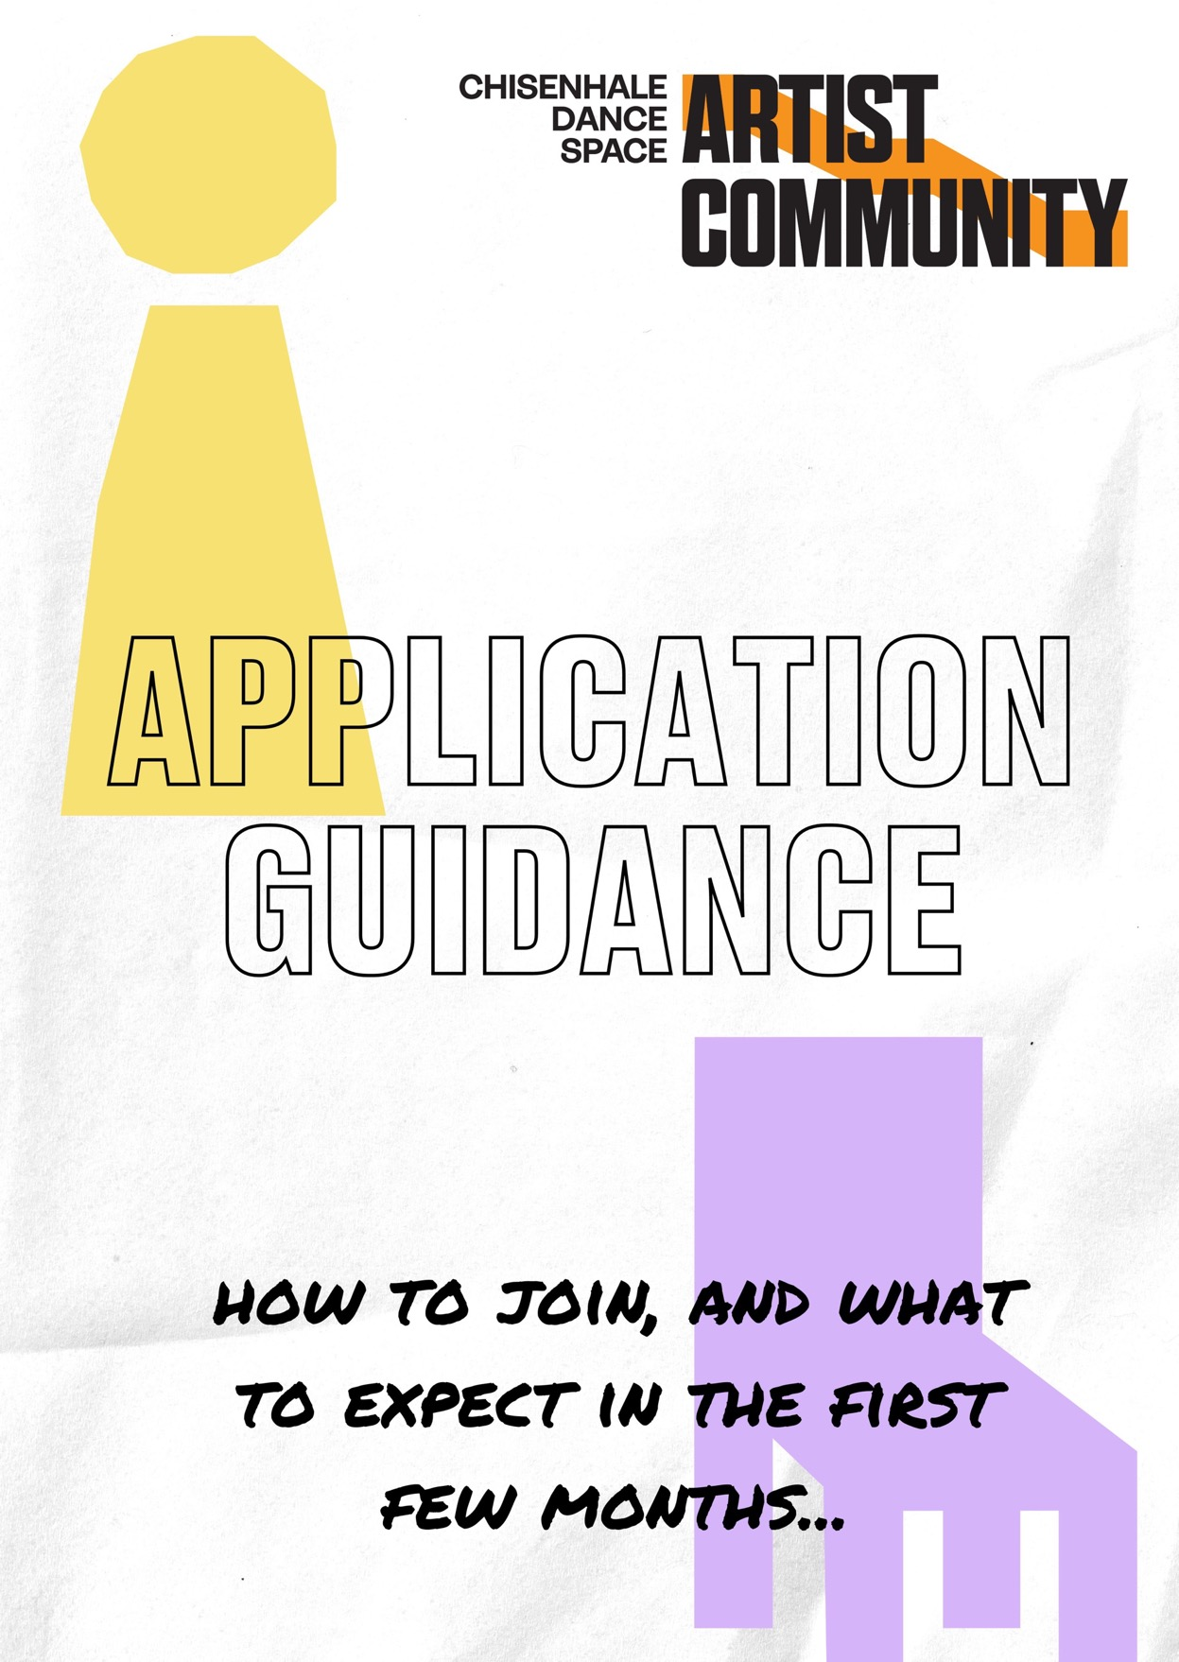

INTRO

We have had a great response since we announced the newly imagined CDS Artist Community in July. Thanks so much to everyone who has reached out in support, and to all those who came along to one of our artist gatherings!

This document is to help you prepare your application to join us, building on the information shared in our full invitation. It also includes info on what you can expect from the first few months of joining.

Click here if you would prefer to listen to a recording of this document. You can also hear artists talk about what the community means to them here.

You can complete the application form here. Applications open on Monday 4th September (6pm) and close Friday 6th October (6pm).

ELIGIBILITY / GUIDANCE

For ease, we've summarised the key eligibility criteria and info you’ll need to consider when applying to join the CDS Artist Community.

Who can join?

- Artists working in dance, performance, live art, or other related practices
- Other arts workers such as producers, curators, teachers and writers
- All disciplines and styles are welcome
- No degree or formal training is needed, and you might not see yourself as a ‘professional artist’
- If you are studying a BA, we ask that you finish before joining.
- You must sign up to our Community Culture, including engaging with a process of reflection on antiracist practice. As part of this, non-black artists need to complete a series of training webinars. Read more here.
All of our selection processes give priority to:
- Artists who have less institutional support, including early career and older artists
- Those who have been historically underrepresented in our community, including black, brown & global majority heritage, and disabled & neurodivergent artists. (More on accessibility on pages 4 and 5.)

Who are Activators and Collaborators?
You can take part in the CDS Artist Community in one of two ways:
Activators are artists who choose to engage regularly with CDS’ activity for a period of up to two years. They are invited to join 4-6 gatherings per year where they work with staff to collectively design and activate CDS’ activity.

Collaborators are artists who feel connected to CDS but may have less frequent time to participate. They receive many of the benefits of being part of the community, but are in a supporting – rather than leading – role.

What are the community’s values?
The CDS Artist Community works in ways that are respectful, transparent, ethical, anti-racist, environmentally-conscious, and non-discriminatory. We explore positive change through the lens of the following ideas: collectivity, autonomy, process, generosity, equity, accountability, and accessibility. You can read more about our community culture here.

How much does it cost?

We suggest £3 per month or £30 per year, but let us know if cost is a barrier. This money is used to leverage more funding from funders, such as Arts Council England, to enable us to support the Artist Community’s projects.

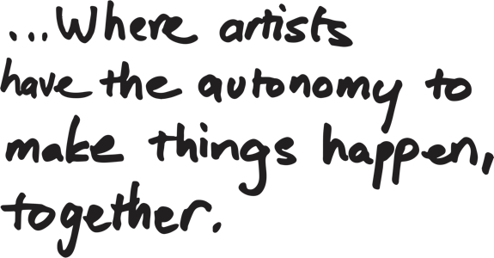
Is your building accessible?

Our imperfect home is on the second floor of a warehouse building, accessed by a staircase only. We regret that we cannot currently adequately support wheelchair users and those for whom stairs are a barrier. We are fighting for a redevelopment on our site that would create lift-access, but we are currently at the early stages of a several-years-long process.

You can read more about the access specifications of our building here.

So, how can disabled artists get involved?
The majority of our activity will continue to be on-site. Therefore if our building is inaccessible to you, we regret that we cannot currently support you to join as an Activator. We are committed to removing other barriers to access, and you can read our commitments to supporting disabled and neurodivergent artists here. We encourage disabled artists considering joining to get in touch to talk about your needs: frances@chisenhaledancespace.co.uk.
We’re working in partnership with Poplar Union, Ugly Duck, Lab13 and Old Diorama Arts Centre to open up more of the community’s activity to a broader range of disabled participants, collaborators and audiences.

ACCESS SUPPORT FOR APPLICANTS

On Weds 20th September from 1 - 2:30pm, Artist Community Producer Frances Morgan will host an informal information session on Zoom. Here you can ask any questions about the application and this will also be a space to take time to fill applications in together. Book a space here.

If you would like one-to-one support to fill in the application, we are very happy to help - over the phone, on Zoom or in person. Please email General Manager Rachel Goodsall: rachel@chisenhaledancespace.co.uk to arrange this.

SELECTION PROCESS
We won’t judge applications on artistic merit, profile or quality. Instead, we are continuing to experiment with lottery-based selection processes, to ensure that artists aren’t being forced to compete with each other unnecessarily.

Applications will first be checked for eligibility by two Artist Committee members and one staff member. This means they will read through applications (anonymised), ensuring they meet the following criteria:

- The applicant has filled in the application fully and explained why they want to join the Artist Community.
- The applicant has broadly understood the purpose of the Artist Community and what it offers.

We will allocate Artist Community places in the following way:

- Fill Activator places from eligible black / brown / global majority / disabled / neurodiverse applicants, ensuring our commitment of at least 50% is reached.
- Allocating the remaining Activator places via a lottery process.
- Allocating up to 150 Collaborator places through a lottery process, including those who were not selected as Activators.

The selected artists will be contacted in the week of 9th October, and asked to accept or decline this offer within two weeks. At this point artists will be asked to supply an image of themselves and a short piece of text describing their practice, for our website and announcement.

THE APPLICATION QUESTIONS

These are the questions that will be included in the online application form. You can also email us an audio / video recording if you prefer. Please send via WeTransfer to: frances@chisenhaledancespace.co.uk

- Personal details including name, email, phone number, and pronouns.
- Do you identify as black, brown / of global majority heritage / a person of colour (or another equivalent term)?
- Do you identify as disabled, neurodivergent, or living with a long-term health condition?
- Do you have any access requirements that you would like to make us aware of? (Read more about how we can support you here).
- Which role would you like to take on, Activator or Collaborator?
- If not selected as an Activator, would you be interested in joining as a Collaborator instead?

- Tell us a bit about your practice – 100-200 words.
- Why are you interested in joining the CDS Artist Community? – 100-200 words.
We'll also ask you a few questions about your availability in the first few months, so that we can estimate numbers for our first couple of gatherings (more on those below).

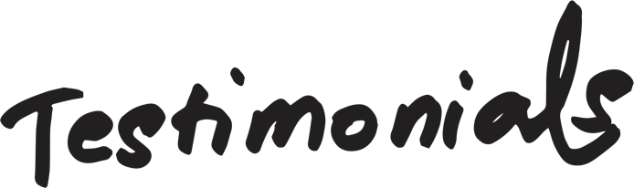


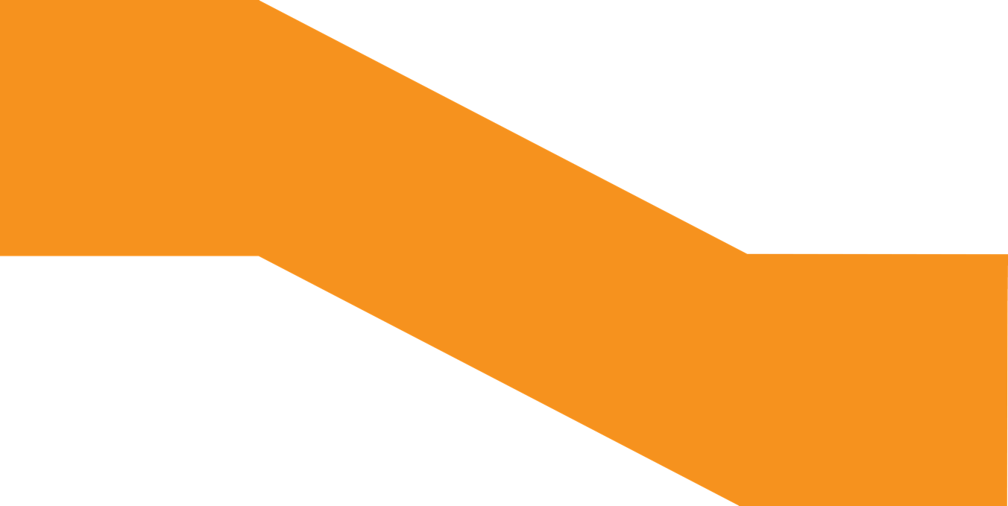
THE FIRST FEW MONTHS
“CDS is the place to make what you want to make, to try what you want to try, and to give yourself space and a community to really explore your art on your own terms. Being part of it isn't just about what you get, it's about what you can build with a community of artists.”
Sam Burkett,
Artist Community
Everyone in the Artist Community will receive a full welcome pack via email in mid-October, with everything you need to know about the community.

Ahead of joining, we thought it would be useful to share some key info, in particular, the first set of events and opportunities that have been designed by our Artist Committee and staff team to kickstart the community.

Artist Community Gatherings
Activators will meet once every 2-3 months and we hope that you’ll be able to come to most of these gatherings. We provide free food and drink, and use these events to set the collective agenda.

Collaborators will meet twice a year at different venues in London, depending on numbers. These are social events with facilitated conversations to enable everyone in the Artist Community to feed in. We will also have zoom sessions as needed.

We’ll aim to set all dates for these gatherings two months in advance.

Thurs 2nd Nov, 7-9pm - Activators Welcome Gathering - At CDS
The first time that Activators come together to meet each other! We’ll provide food and drink, and lead an induction on how the space and community work. We recommend that all Activators attend if you can.

Thurs 9th Nov, 7-8:30pm - Artist Community Welcome Zoom - Online
The first time that Activators and Collaborators come together. We’ll explain how to get involved and give you time to meet some of your fellow artists. It’s ok if you can’t make it!

Thurs 14th Dec, 7-9pm - Artist Community Winter Party – At CDS
This is our end of year gathering, open to everyone in the community. There will be music, food, conversation, and entertainment!
Regular Gatherings for Marginalised Artists
We'll host alternating community-building events every two months for disabled / neurodivergent artists and for black / brown / global majority artists. These provide an opportunity to artists both inside and outside our community to meet, share free food, and explore their creativity. We’ll announce the dates for these in October.

OPPORTUNITIES

To kick-start the community, CDS staff and the Artist Committee have designed some opportunities for the first few months, described below.

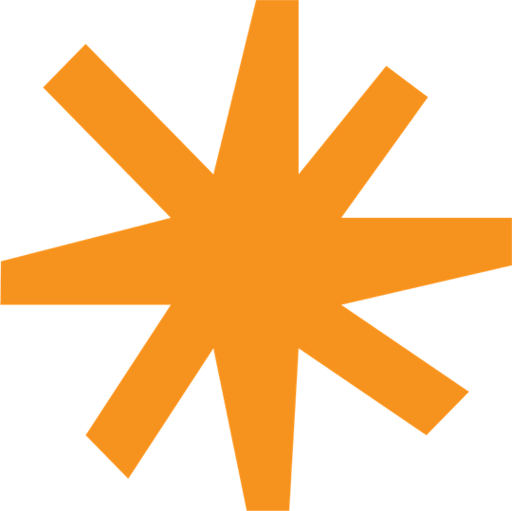
Beyond that... we don’t know yet! We’ll meet with Activators to begin the process of designing, funding and resourcing new artist support opportunities in response to your needs. In previous years we have supported scratch nights, artist-led workshops, advice surgeries and residencies.

Winter Workshops

This winter we will host a three-day intensive with free workshops and opportunities for artist networking, split between CDS and an offsite partner venue (wheelchair accessible). This is an opportunity for the Artist Community to take more time to get stuck into collective organising, learning from each other, and experimenting with new ways of working. Plus, there will be food, social events, and a performance party to celebrate the launch of our community. We’re still ironing out the details, but will be able to say more soon!
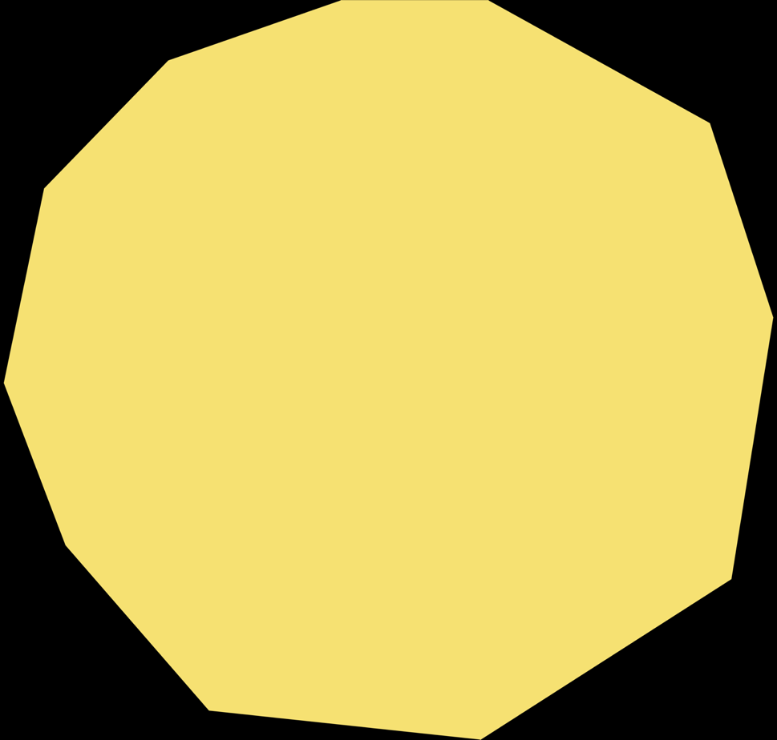

Greenhouse

Greenhouse will be a bespoke development programme for eight Activators who have the beginnings of an idea, project, production, or concept but need creative support, skills development and time to help realise their vision.

It is specifically an opportunity for Activators who identify as black / brown / global majority, or disabled / neurodivergent that will provide:
- Seed funding of £500
- Group workshops and peer-to-peer support
- Tailored development plan
- Mentorship and pastoral support from CDS team, including support to write a funding application
Greenhouse will particularly benefit artists who are in the early stages of their career and have never applied for funding or had the opportunity to develop an idea beyond the studio.

Applications for Greenhouse will open in early November and the programme will start in December.

WTF Thursdays

WTF Thursdays is back this Autumn. Each Thursday, CDS hands over the keys to the building for free, for an artist to host an event. This programme works in the spirit of low-stakes, DIY action, and hosts offer their time as a gift to other artists. By hosting once, you are contributing to a varied programme of 40+ free experiences for the artist community every year. Learn more about how to get involved here.

In October/November we will announce more opportunities and events, including paid, artist-led Coffee Mornings, a community peer-to-peer support system, and advice sessions with CDS staff.

If you have any questions, please contact Frances Morgan, Artist Community Producer: frances@chisenhaledancespace.co.uk

You can complete the application form here. Applications open on Mon 4th September (6pm) and close Fri 6th October (6pm).

We’re excited to receive and read your applications, and hope to see you soon!

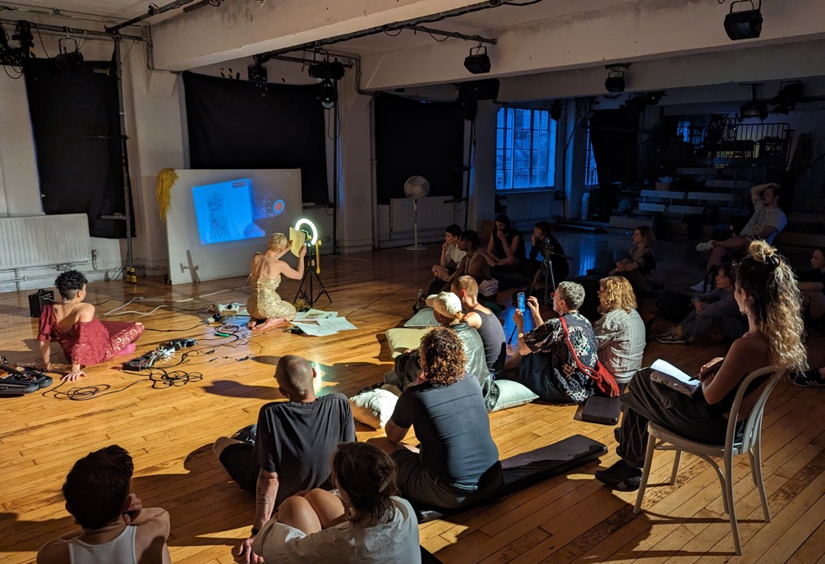
WTF Thursdays: Queer Salon, August 2023, Hosted by Claudia Palazzo.
Performers pictured: Alina Maldonado and Tallulah Haddon.

