

Chisenhale Dance Space - General Manager

Background

The organisation
Chisenhale Dance Space (CDS) is East London’s champion of experimentation in dance and performance, based in Bow for 40 years. Our programme is made by, with, and in response to our Members, and to date has consisted of:
- subsidised-cost rehearsal space
- artist support programmes
- a boundary-pushing performance programme in our venue and beyond
- participation and education projects in Tower Hamlets]

We are a space hire organisation, and this forms a core part of our income. We have two main dance studios that we hire.

CDS is one of the three independent charities that occupy Chisenhale Art Place in a former veneer factory on Chisenhale Road, alongside the separate Chisenhale Gallery and Chisenhale Studios. Our ex-warehouse on a back-street by Victoria Park was home of the influential ‘New Dance’ movement in the 80s and 90s, with our artists expanding both the form and active politics of movement, changing the face of UK dance. These experimental, urgent approaches have continued throughout our history and continue to be reflected in the Membership and our programmes. Our Space and location in the community of Bow has always formed a key element of CDS’ identity and programme.

The following core values are at the heart of everything the organisation does:
- Communal - Adj. “shared by all members of a community; for common use”
- Venturous - Adj. “willing to take risks or embark on difficult or unusual courses of action”
- Physical - Adj. “relating to the body; to things perceived through the senses; tangible or concrete”
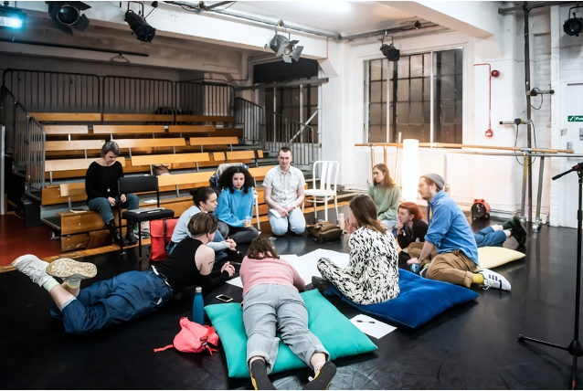

CDS Members, staff and trustees at the 2022 Annual General Meeting. Photo by Lidia Crisafulli.

A period of organisational change
CDS is entering a time of transformation post-pandemic, as it reckons with its inherited structures, and assesses how to change to better serve its communities. This is an exciting time to be joining CDS as we undergo an organisational review to streamline how we work, interrogate our business model and rearticulate our commitment to supporting members and independent artists.

CDS appointed a new Executive Director in August 2022 to lead on this process. This recruitment of a newly refreshed General Manager role is integral to this process, contributing to the overall in progress revisioning of what CDS is and who it is for:

- Like many other arts organisations, CDS is having to explore alternative business models that go beyond its inherited structures. This includes exploring new financial and funding models, innovative partnerships and new ways of working as a staff team. The board has made the decision to pause some of the organisation's activities to make the space needed to implement new and more sustainable business models.

- The pandemic has accelerated overdue conversations about the systems of exclusion that operate within CDS. We began an organisation review that seeks to make significant progress towards CDS being an anti-racist and anti-ableist organisation, with us us still on that journey. Our staff, Board and members have taken part in anti-racism training, and CDS is committed to continuing this learning in an open and transparent way.

- We intend for CDS members to become more fully integrated in the decision making and artistic direction of CDS going forwards, and our work as an organisation is orientated towards this goal. Membership revisioning and the outcomes of that will inform the structure for the next phase of leadership for CDS, with the staff team playing a key role in this thinking.

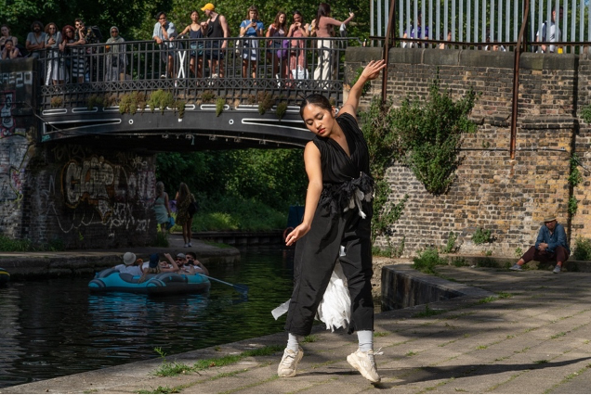
Dance of the Bow Magpie by Quang Kien Van, Encounter Bow, June 2021. Photo by Zbigniew Kotkiewicz.

The Role

Job Title: General Manager
Contract Type: Permanent full-time
Start Date: To be negotiated, ideally Jan 2023
Salary: £28,000 FT
Pension: 3% employers’ contribution
Annual leave: 20 days + statutory bank holidays, which equates to 28 days for a full-time employee, or 5.6 weeks.
Line Manager: Executive Director
Manages: Freelancers & Venue Assistants, as required
Close Working Relationships: Executive Director, Producer: Membership

Days of work: Monday to Friday, however the business is open 7 days a week. Where you are required, with notice, to work a weekend, time off in lieu will be arranged.
Normal Hours of work: 40 hours per week to be worked on Monday to Friday 9:30am to 5:30pm.

Location: To work full-time from our offices at Chisenhale Dance Space (64-84 Chisenhale Rd, Bow, London E3 5QZ)
About the Role:
The General Manager is responsible for the day to day operations of CDS, managing the building, events and people within it. They provide the glue that holds the organisation together and will be a key figure in the team, often being the first point of contact for those interacting with CDS.

As a member of the management team, they will work closely with the Executive Director on business planning and operational work plans to ensure CDS makes best use of the resources available to us, and that our studio spaces are busy and the people using them are happy. They will be responsible for maximizing every opportunity they can to keep our building active, seeking out and responding to new opportunities and overseeing the planning and delivery of events and activity for members, artists and audiences in collaboration with the Producer: Membership.

This is a great opportunity for an arts, events, office or stage manager looking for a new challenge, an experienced freelancer looking to work in a venue for the first time or someone with lots of the right skills that wants to take a step up. We’re looking for someone who wants to contribute to making active change, is eager to work as part of a dynamic team and who is excited to put their stamp on the role and the organisation by bringing bold new ideas.

The General Manager will work closely with the Executive Director, supporting them as required and as directed by them, in the following areas:

Studio Hires
- To be the key, timely, point of contact for all space hire enquiries and cultivate relationships with regular space users, including members, artists, local residents, teachers and commercial hirers.
- To innovate and manage the rebuilding of CDS’ studio user base as a significant income source for the organisation, seeking new partnerships with regular hirers and teachers
- To strategize, resource, oversee and deliver marketing activities for studio hires and to promote the activity that takes place in our building
- To manage CDS’ online space hire booking system and coordinate block bookings including email correspondence, invoicing and payment follow-up
- Maintain efficient and clear online and office procedures for space hire booking
- To ensure CDS’ website is up to date for all operational areas of activity, including updating copy, terms of agreements and systems are working well - ie online booking processes

Events & Project Management
- To collaborate with the Executive Director and Producer: Membership to plan, manage and deliver an internal programme of performances, activity and events
- To manage the booking and running of external performance hires and other bespoke events that take place in the building

Operations
- To manage the Venue Assistants, ensuring the building is staffed on evenings and weekends when necessary.
- To oversee efficient, safe, compliant and effective management of CDS’ venue operations, ensuring necessary licenses and certificates are in place.
- To take care & pride in the building by managing a regular programme of monthly & annual maintenance of the studios and the building CDS occupies.
- Manage relationships with users, teachers, service providers and landlords to ensure that CDS studios are a clean, safe, compliant and a welcoming place for dance and related activities. To line manage any freelance contracted staff CDS employs and to oversee their work.
- Manage commercial systems including point of sale, CRM, payment gateways, e-commerce, access codes and financial record keeping
- To be the main on-site point of contact for enquiries and studio users.
- General housekeeping of office facilities.
- Work with CDS’ cleaning contractor to ensure that the studios are well presented and hygienic.
- To ensure that CDS has operable policies pertaining to all operations, including but not limited to Health & Safety, Safeguarding, EDI, and Grievance and Complaints

Financial
- To manage and support financial administration, in collaboration with the Executive Director and the external book-keeping company
- To oversee management and report on Operational and space hire budgets - including monthly reporting on space hire, including POS reports
- To ensure financial systems pertaining to operations and space hire are in place with the Executive Director, and suggest improvements to systems for income generation where possible
- To assist in the Executive Director in ensuring that all staff, contractors and statutory bodies are paid on time, including having access to online banking

Other Misc. Duties
- To support the Executive Director in fundraising where required, from grant and donor sources, including Arts Council England, Trusts and Foundations, and statutory bodies. Including identifying opportunities to support core costs, writing applications, information gathering, and collation of statistical evidence for applications
- To maintain the strategic relationship with the local stakeholders including but not limited to the organisations within the Chisenhale building, immediate local residents, and contacts from the London Borough of Tower Hamlets and funders
- Attend events and networks on behalf of CDS, and represent our interests where possible, as directed by the Executive Director

Person Specification

Essential:
- Experience working in an arts, community or other comparable organisation
- An ability to think creatively and strategically, finding solutions to problems as they arise
- Practical understanding of the operation and running of an arts venue
- Experience of project management
- Interest or experience in dance and/or other art forms in the creative & cultural industries
- Experience managing budgets and supporting financial administration
- Strong IT skills with knowledge of softwares you use
- Excellent communication skills, both verbal and written, and the ability to relate well to a wide range of people
- Strong attitude to team working and ability to work efficiently within a small team
- Commitment to equality, diversity and inclusion working practices

Desirable:
- Experience managing community projects & working with community partners
- Experience with fundraising from a range of sources
- Experience managing and developing commercial income
- Awareness of revenue drivers in arts sector
- Experience managing people
- An understanding of the needs of, or experience working with, dance and performance artists
- An understanding of the social landscape of Bow and East London

You do not have to have done this exact job before or tick all the criteria. We’re looking for someone with enthusiasm and tenacity, a commitment to creating a space where artists can thrive and the ability to step into this busy, exciting role at the heart of the team.

Please send the following to reece@chisenhaledancespace.co.uk by the deadline below:
- full CV, with two referee contacts (only contacted if offered role)
- No more than 2 A4 page covering letter OR a 5-minute video telling us why you’re the right person for this role
- Please complete the equality and diversity monitoring form by clicking here.
We encourage applications from those who are under-represented in our organisation and marginalised in our sector and society, especially those from the global majority, including those of African diaspora heritage, South Asian, East Asian, South-East Asian heritage, mixed heritage, and those who have faced other socio-economic barriers and disabled people. Applicants from one or more of the above under-represented groups who can demonstrate they meet a majority of the essential criteria will be invited to interview.
We want our interview process to be open and friendly. We don't want to add pressure onto what already can be a stressful situation, so we will send interviewees our questions and the names of the panel members in advance of the interview to better reflect our working environment. If able to attend in person, we’ll invite you to the building for a tour and to meet the team. If you have any access needs for the interview, we will meet them. We will offer individual feedback to all unsuccessful candidates if requested.
Applications Open: Friday 21st October 2022
Deadline: Midnight, Friday 18th November, 2022
Shortlisted applicants informed: by end of Wednesday 23rd November, 2022
Interviews:
Monday 28th November, Tuesday 29th November OR Wednesday 30th November (in person preference, online option available if required for travel or access reasons, please let us know availability)
Start date: Early Jan 2023, exact date negotiable

If you have questions about this opportunity, informal conversations prior to application can be arranged with Executive Director, Reece McMahon. Please contact reece@chisenhaledancespace.co.uk to arrange.

