

Application Pack:
Executive Director

Are you a person passionate for supporting change, with strong financial management skills and an ethos of care for the people you work with?

Chisenhale Dance Space is seeking an experienced Executive Director to lead the organisation from late August 2022 for an initial 8-month period, with the ambition to extend. This period will cover an organisational review including business re-modelling, careful financial management and continued recovery following the impact of the pandemic.

The Executive Director will lead the CDS Board, staff, key stake-holders and change-makers to identify how CDS might radically transform itself into a more sustainable business model and begin implementing these changes in a strategic and timely way - underpinning the overall in progress revisioning of what CDS is and who it is for.

We encourage applications from those who are under-represented in our organisation and marginalised in our sector and society, especially those from the global majority, including those of African diaspora heritage, South Asian, East Asian, South-East Asian heritage, mixed heritage, and those who have faced other socio-economic barriers, those who identify as LGBTQ+, and disabled people.

Background

The organisation
Chisenhale Dance Space (CDS) is East London’s champion of experimentation in dance and performance. We’re an artist Member-led organisation, based in Bow for 40 years. We operate as a member-led organisation that works with our local community on various education and participation projects and opportunities. We are a commercial space hire organisation, and this forms a core part of our income. We have two main dance studios that we hire. Our programme is made by, with, and in response to our Members, and to date have consisted of:
- subsidised-cost rehearsal space
- open-access classes for children
- artist support programmes
- a boundary-pushing performance programme in our venue and beyond
- participation and education projects in Tower Hamlets

CDS is one of the three independent charities that occupy Chisenhale Art Place in a former veneer factory on Chisenhale Road, alongside the separate Chisenhale Gallery and Chisenhale Studios. Our ex-warehouse on a back-street by Victoria Park was home of the influential ‘New Dance’ movement in the 80s and 90s, with our artists expanding both the form and active politics of movement, changing the face of UK dance. These experimental, urgent approaches have continued throughout our history and continue to be reflected in the Membership and our programmes. Our Space and location in the community of Bow has always formed a key element of CDS’ identity and programme.

Prior to the pandemic, business model innovations led to a more sustainable model with core costs covered by earned income from space hire and classes. However, CDS is now needing to look again at its operating and income generation models to ensure continued growth and support for its member artists and cultural provision for its local Bow community.

CDS is entering a time of transformation, as it reckons with its inherited structures, and assesses how to change to better serve its communities. The following core values are at the heart of everything the organisation does:
- Communal - Adj. “shared by all members of a community; for common use”
- Physical - Adj. “relating to the body; to things perceived through the senses; tangible or concrete”
- Venturous - Adj. “willing to take risks or embark on difficult or unusual courses of action”

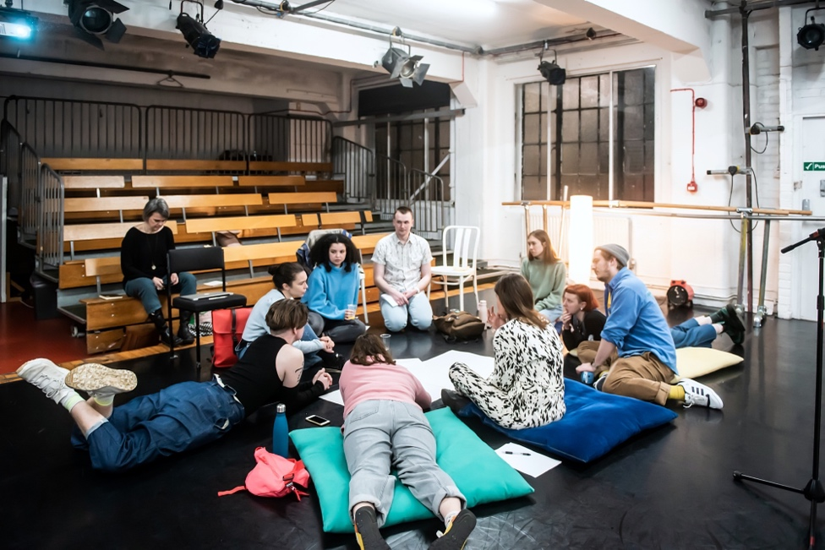

CDS Members, staff and trustees at the 2022 Annual General Meeting. Photo by Lidia Crisafulli

The role
The Executive Director will work with CDS’ Board, staff and commissioned change-maker to streamline the organisation’s operating and business model. They will manage the overall organisation finance and governance, supporting and leading the current team through the interim period, overseeing the organisation’s exploration of alternative models for the future.

Context
For CDS’ survival through the pandemic we are hugely thankful for life-saving investment from diverse local, national, regional funding bodies, trusts and individuals, which demonstrates the value of CDS’ survival to our local and artistic communities, and as a part of London’s arts infrastructure.
CDS started the 2022-23 financial year with reflated reserves, and significant confirmed grants from the Arts Council England Culture Recovery Fund Round 3, Backstage Trust and Action for Bow. Further grant applications have and will be made over the course of this summer to contribute to core costs as well as the continuation of our revisioning of CDS’ membership and refining what it is and how our membership model functions.

Organisational change
This is a critical time for CDS and the Executive Director will be a key conduit, alongside a commissioned change-maker, between CDS’s members, staff and board to identify how we might radically transform the business into a more sustainable model. They will lead on imagining and implementing these changes in a strategic and timely way. This will underpin the overall in progress revisioning of what CDS is and who it is for:

- Like many other arts organisations, CDS is having to explore alternative business models that go beyond its inherited structures. This includes exploring new financial and funding models, innovative partnerships and new ways of working as a staff team. The board has made the decision to pause some of the organisation's activities, including the participation programme, to make the space needed to explore and implement new and more sustainable business models.

- The pandemic has accelerated overdue conversations about the systems of exclusion that operate within our organisation. We began an organisation review that seeks to make significant progress towards CDS being an anti-racist organisation. The organisation is still on that journey. We are happy to be transparent about this, as we have been with the Membership. Our staff, Board and members have taken part in anti-racism training, and CDS is committed to continuing this learning.

- The Membership revisioning and the outcomes of that will inform the structure for the next phase of leadership for CDS and the Executive Director will play a key role in this planning. The intention is for CDS members to become more fully integrated in the decision making and artistic direction of CDS going forwards, and our work as an organisation is orientated towards this goal.

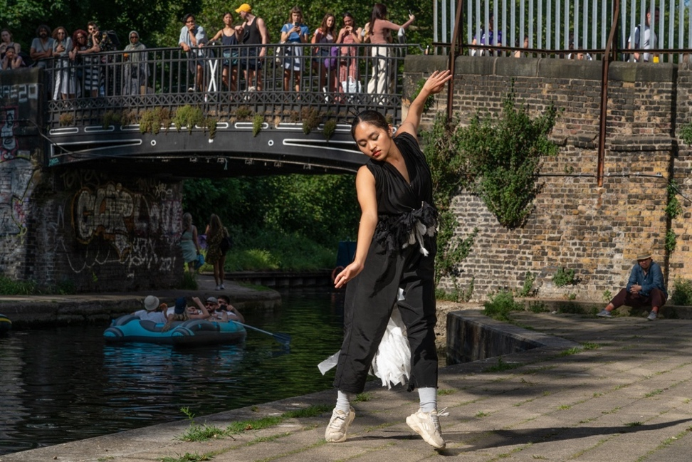

Dance of the Bow Magpie by Quang Kien Van, Encounter Bow, June 2021. Photo by Zbigniew Kotkiewicz.

Job Description

Job Title: Executive Director
Contract Type: Fixed term contract late August 2022 - end of March 2023 (with potential to extend). Part time, 0.8 FTE.
Salary: £40,000 p/a, pro rata
Pension: 3% employers’ contribution
Annual leave: 20 days + bank holidays (pro rata)

Line Manager: Board of Trustees
Manages: two direct reports, plus freelancers

Location: It is anticipated that the Executive Director would work from our offices at Chisenhale Dance Space at least 3 days / week, with 1 day working from home if desired.

The Executive Director is responsible for the financial management and fundraising for the organisation. They will support the Producer: Membership with membership revisioning managing and supporting the staff team, working with the Operations Manager & Producer: Participation to ensure the smooth running of the building alongside maximising income from space hire. They will work with Trustees to ensure that a viable future for CDS is achieved including working closely with them and change-making processes and freelancers.

It is a role intended to ensure forward movement, all the while ensuring proper management and financial viability of the organisation. It assists the Producer: Membership and Operations Manager & Producer: Participation to make decisions and lead programmes in their remit.

Strategy and Organisational Change
- To work with the Trustees, Members and core staff to lead the charity’s vision and aims, combining effective business management with community engagement and artist-led support
- To project manage a sixth-month programme of organisational review and feed into the recruitment process for a future Leadership model for CDS
- To work with the Producer: Membership to manage members and external consultant(s) for the Membership revisioning
- To develop networks and partnerships pertinent to the process of change-making and organisational review with the Trustees, Members and staff
- To manage strategic organisational communications with Membership, public, partners and stakeholders regarding the change process
- To oversee the finalisation of operable policies for CDS, with support from core staff

Financial
- To retain full organisational responsibility for banking, budgeting, monitoring, reporting and management of the company accounts.
- To oversee staff’s management of project budgets and support of financial systems/ processes
- To manage external book-keeping company and Independent Financial Examiners.
- To ensure that all staff, contractors and statutory bodies are paid on time.
- To oversee payroll (external) and ensure that HMRC and pension contributions are paid.
- To manage CDS’ bank account and signatories.

Fundraising and income generation
- To identify and lead on fundraising from grant and donor sources together with CDS’ Board of Trustees
- To support the Operations Manager & Producer: Participation & Producer: Membership and Operations Manager on fundraising from grant and donor sources, including Arts Council England, Trusts and Foundations, and statutory bodies, maintaining organisational oversight on project funding.
- To ensure that CDS’ earned income streams (eg space hire) are maximised and contribute to a mixed and sustainable business model

Marketing and Communications
- To manage and oversee marketing strategy and delivery across core staff team, including working with freelancers
- To manage and oversee with core staff team and marketing freelancers the implementation of a new CDS website global template and navigation system for CDS and its key operating and income areas including space hire

Team
- To line manage PAYE and freelance staff, as designated
- To work with external contractor myHRdept to ensure that all staff’s working is contractually compliant and in line with employment legislation

Governance
- To report to, and collaborate with, the CDS Board of Trustees on the strategy and decision making
- To be Company Secretary for CDS, and work with the Board on annual and quarterly reporting and management accounts
- To contribute to the ongoing development of the Board of Trustees

Chisenhale Art Place
- To work closely with Chisenhale Art Place (CAP), Chisenhale Gallery and the artists of Chisenhale Studios to ensure a collaborative, co-operative cohabitation of the Chisenhale Works building and its future development
- To report on CDS to CAP Trustees meetings and AGM

Person Specification

Essential:
- Experience leading and managing teams.
- Strong financial management skills which include the setting and managing budgets including overall organisational finances, including mixed income streams.
- Excellent organisational, prioritisation and time management skills.
- An understanding of charity governance.
- Experience with fundraising from a range of arts and non-arts sources.
- Experience in a senior or executive role in an arts organisation.
- Experience working with a Board of Trustees.

Desirable:
- An understanding of inclusion and anti-racism in charities or the arts.
- An understanding of the artistic and/or local ecology in which CDS operates.
- Experience managing organisational change.



Flora Wellesley-Wesley leads a workshop with local people as part of Chisenhale Summer of Art 2021

Apply

Please send the following to opportunities@chisenhaledancespace.co.uk by the deadline below:
- full CV, with two referee contacts (only contacted if offered role)
- No more than 2 A4 page covering letter OR a 5-minute video telling us why you’re the right person for this role
- Please complete the equality and diversity monitoring form by clicking here.

Deadline: 10am, Monday 25th July, 2022
Shortlisted applicants informed: by end of Wednesday 27th July, 2022
Interviews:
Tuesday 2nd August 2022 (first interviews via Zoom)
Tuesday 9th of August 2022 (Optional follow-up via Zoom - tbc)
Start date: Tuesday 30th August 2022

If you have questions about this opportunity, informal conversations can be arranged with Trustees or outgoing Interim Chief Executive Ruth Holdsworth. Please contact opportunities@chisenhaledancespace.co.uk or ruth@chisenhaledancespace.co.uk to arrange.

Access
If this process is not accessible to you, please leave a voicemail message on the office number (020 8981 6617) or email theboard@chisenhaledancespace.co.uk for assistance and to discuss an alternative format of application.

We would like to encourage disabled people to apply. Regretfully, Chisenhale Dance Space is in an old building and only accessed by a staircase and therefore is not wheelchair accessible. However we are eager to make other adjustments as necessary to suit an individual’s needs, and to support applications to claim Access to Work as relevant.

