

Application Pack:
Classes Coordinator

Background

The organisation

Chisenhale Dance Space (CDS) is East London’s champion of experimentation in dance and performance. We’re an artist Member-led organisation, based in Bow for 40 years. Our programme is made by, with, and in response to our Members, and currently consists of:

- subsidised-cost rehearsal space
- open-access classes for children
- artist support programmes
- a boundary-pushing performance programme in our venue and beyond
- participation and education projects in Tower Hamlets

CDS is one of the three independent charities that occupy Chisenhale Art Place in a former veneer factory on Chisenhale Road, alongside the separate Chisenhale Gallery and Chisenhale Studios. Our ex-warehouse on a back-street by Victoria Park was home of the influential ‘New Dance’ movement in the 80s and 90s, with our artists expanding both the form and active politics of movement, changing the face of UK dance. These experimental, urgent approaches have continued throughout our history and continue to be reflected in the Membership and our programmes. Our Space and location in the community of Bow has always formed a key element of CDS’ identity and programme.

Chisenhale Dance Space’s Children’s Classes play an active role in providing young local residents and families with opportunities to participate in physical and creative activities, maintain and improve health and mental wellbeing as well as keeping the community connected. Our Creative Movement & Dance Classes nurtures the creative futures of nearly 200 local children each term. Our fun, creative classes allow children alongside their parents/carers to explore different qualities of movement, learn contemporary dance skills and create their own choreography through games, partner work and structured improvisation. This programme contributes to building and sustaining a vibrant and inclusive local community,

Following the lifting of COVID-19 restrictions, we were overjoyed to return to a more extensive classes programme from Autumn 2021, which optimises our highly professional Performance Studio and Research Studio to create safe spaces and support young people’s learning and development following COVID-19.

CDS is entering an exciting time of transformation and growth, as it reckons with its inherited structures, and assesses how to change to better serve its communities. The following core values are at the heart of everything the organisation does:
- Communal - Adj. “shared by all members of a community; for common use”
- Physical - Adj. “relating to the body; to things perceived through the senses; tangible or concrete”
- Venturous - Adj. “willing to take risks or embark on difficult or unusual courses of action”

Classes Coordinator

Job Title: Classes Coordinator
Contract Type: Fixed term contract until 2nd April 2022
Part time, 15 hours per week.
Available to work on Saturday’s from 9am - 2pm
Start date: Immediate start following offer of role (Saturday 8th January 2022)
Salary: £22,425 per annum, pro rata (London Living Wage/Full time equivalent)
Pension: 3% employers’ contribution
Annual leave: 20 days + bank holidays (pro rata)
Line Manager: Operations Manager & Producer: Participation
Location: The role is based at Chisenhale Dance Space, London E3 and due to the nature of the role, home working is not possible.

CDS is an equal opportunities employer and all candidates are welcome to apply, irrespective of their background, gender, disability status, religion or beliefs. We encourage applications from those who are under-represented in our organisation and marginalised in our sector and society, especially those from the global majority, those who have faced socio-economic barriers, those who identify as LGBTQ+, and disabled people.

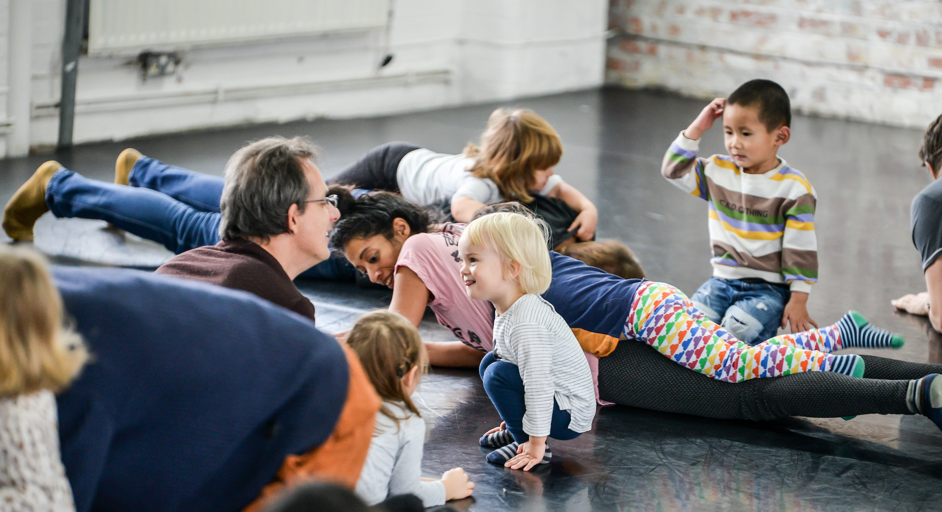

Children's Dance Classes at Chisenhale Dance Space
Job Description

As Classes Coordinator you will work closely with the Operations Manager & Producer: Participation in delivering CDS’s Children’s Classes programme efficiently and to the highest standard. In recent years CDS has focussed on continued change towards greater inclusivity, open-access participation, and a deeper and more relevant connection to our local Bow community. With funding received from Action for Bow, this role will support improving access and widening our local relationships with families, children, educational institutions and community providers to recruit and allocate free places and bursaries for classes.

CDS Classes
- To support the Producer: Participation as a main point of contact for classes enquiries and bookings
- To duty manage the studios and the delivery of classes on Saturday mornings in term time
- Work with the freelance classes tutors and cleaning contractors to ensure the smooth and safe running of the classes, including compliance with COVID protocols
- To support the Producer: Participation in assisting customers with registration for classes, and provide support to clients making bookings online
- To oversee the classes registers, ensuring all information is correct and up to date.
- Process sales and registrations for classes using POS system
- Update Producer: Participation with a weekly classes report including attendance figures, enquiries and communications.
- Recruit participants to attend CDS Children’s Dance Classes, including writing web/email copy, social media posts and carrying out email/phone communications to engage the local community.
- Schedule dates and times for freelance dance teachers in 2 half termly planning meetings, minute meetings and circulate actions.
- Collate data/regular feedback from Classes participants and parents/carers to share with Producer: Participation and feed into evaluations.
- Maintain CDS contact databases of participants, local schools and community partnerships, ensuring all information is correct and up to date.

General
- To attend weekly staff meetings, training sessions and other events, which may sometimes take place outside normal working hours. Any additional hours must be agreed in advance by both parties and will be reimburse with time off in lieu.
- Undertake other duties considered reasonable by Chisenhale Dance Space.
Please note: This position involves working with children & young people, therefore, all appointments will be subject to a satisfactory enhanced Disclosure & Barring Service Check.

Person Specification

Essential
- Excellent time management, communication and administrative skills.
- Excellent computer skills, with a range of software and web-based apps.
- A team player and able to work collaboratively and support colleagues.
- Strong organisational skills with the ability to coordinate people.
- Excellent interpersonal and communication skills, both written and verbal.
- Ability to work on own initiative and meet deadlines.
- A systematic and efficient approach to working.
- Experience with marketing including social media.
- Ability to work independently, and sometimes alone in CDS’ offices.

Desirable
- Experience of working on participatory arts projects with early years, children, young people.
- Experience of dance and/or performing arts and the needs of those industries.
- Knowledge of health and safety and accessibility in a dance learning context.
- Experience of using box office or POS systems.
- Experience with retail or taking payments for services in another form.
- First Aid qualification.
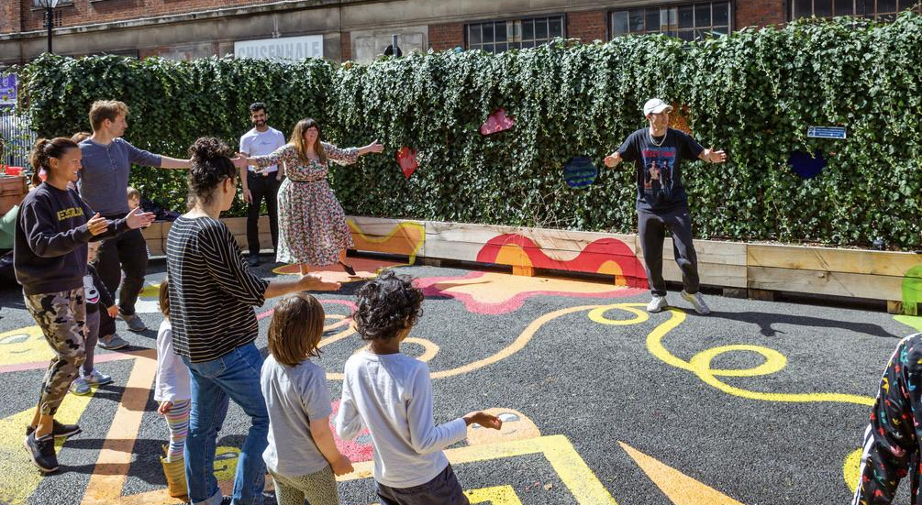
Chisenhale Summer of Art Programme at Chisenhale Learn Play Create

Apply

Please send the following to jessica@chisenhaledancespace.co.uk by the deadline below:
- full CV (no more than 2 sides of A4)
- covering letter telling us why you’re the right person for this role (no more than 2 sides of A4)
- a completed Equal Opportunities Monitoring Form (optional). This is to support our commitment to be an equal opportunities’ employer and to improve the representation and diversity of our workforce.

Deadline: 5pm, Wednesday 15th December 2021
Shortlisted applicants informed: Friday 17th December 2021
Interviews: Afternoon of Tuesday 4th January 2022 (please hold availability)
Start date: ASAP (Saturday 8th December 2022)

If you have questions about this opportunity, informal conversations can be arranged with Operations & Education Manager, Jessica Richards. Email jessica@chisenhaledancespace.co.uk to arrange.

Access

If this process is not accessible to you, please leave a voicemail message on the office number (020 8981 6617) or email jessica@chisenhaledancespace.co.uk for assistance and to discuss an alternative format of application.

Regretfully, Chisenhale Dance Space is in an old building and only accessed by a staircase and therefore is not wheelchair accessible. However, we are eager to make other adjustments as necessary to suit an individual’s needs, and to support applications to claim Access to Work as relevant.

