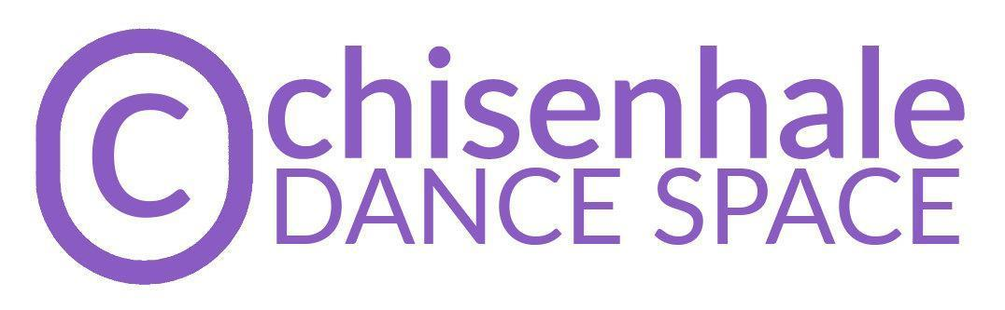
BOARD RECRUITMENT PACK 2021

Chisenhale Dance Space is looking for new Trustees of the Board, including a new Chair of the Board

Support the organisation as it continues on a journey of sustainable, increased public-facing activity, championing under-represented artists making dance and performance.

Chisenhale Dance Space (CDS) is navigating a period of change and renewal, exploring how it can transform to best support its communities in the decades to come. We are looking for up to five passionate, generous, enthusiastic and pro-active board members that can help stir the organisation through the dynamic years ahead.
To tackle the challenges and opportunities faced by the organisation, CDS is seeking board members who will bring a broad range of skills and experience. This includes, but is not limited to, expertise in: performing arts practice, community-embedded arts practice, property law, finances and budget management, governance and board management… more details below.

We recognise that people with different lived experiences will bring different knowledge to the organisation, and that this is critical for a healthy, vibrant and inclusive organisational ecology. We encourage applications from those who are under-represented in our organisation and marginalised in our sector and society, especially those from the global majority, including those of African diaspora heritage, South Asian, East Asian, South-East Asian heritage, mixed heritage, and those who have faced other socio-economic barriers, those who identify as LGBTQ+, and disabled people. We regret that CDS is currently located in a historic building which currently has no step-free access. We have long-term plans to remedy this, as part of changes to enable more people to take part in our activities. We are happy to discuss access arrangements with anyone looking to join the board.

We have below appointed roles for Trustees, some of which we are currently recruiting for:
- Chair of the Board (recruiting)
- Vice Chair
- Equality, Diversity and Inclusion Lead (recruiting)
- Treasurer (recruiting)
- Human Resources Lead
- Artistic Community Leads (recruiting)
- Building / Legal Lead (recruiting)
- Outreach and Community Lead

Being a Trustee of a charitable organisation is a voluntary position. However, costs to enable engagement can be covered by the organisation - such as travel, access support or caring responsibility support.

This pack contains the following sections:
- About Chisenhale Dance Space
- About the Board of Trustees
- Specific Roles - details of vacancies on the board
- How to Apply

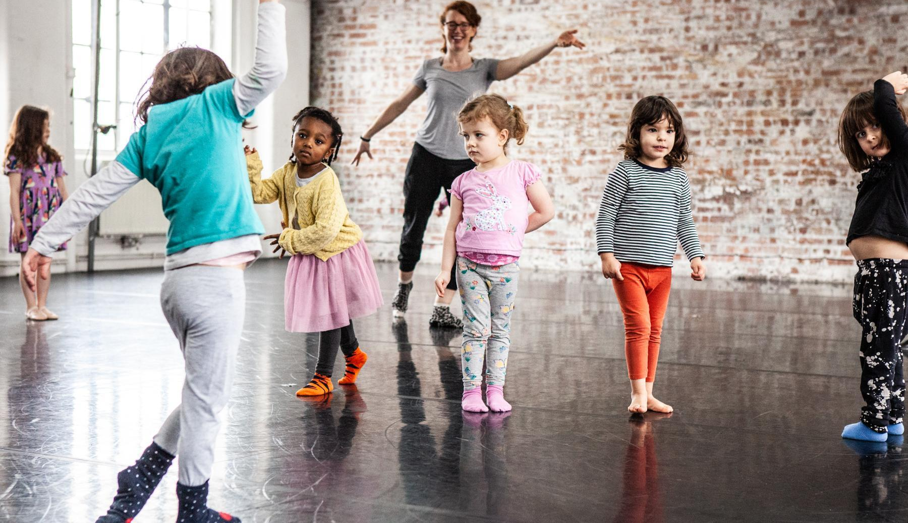

Children’s Creative Movement Classes. Photo by Zbigniew Kotkiewicz

About Chisenhale Dance Space
East London’s champion of experimentation in dance and performance.

We’re an artist Member-led organisation, based in Bow for 40 years. Our programme is made by, with, and in response to our Members, and currently consists of:
- subsidised-cost rehearsal space
- open-access classes for children
- artist support programmes
- a boundary-pushing performance programme in our venue and beyond
- participation and education projects in Tower Hamlets

CDS is one of the three independent charities that occupy Chisenhale Art Place in a former veneer factory on Chisenhale Road, alongside the separate Chisenhale Gallery and Chisenhale Studios. Our ex-warehouse on a back-street by Victoria Park was home of the influential ‘New Dance’ movement in the 80s and 90s, with our artists expanding both the form and active politics of movement, changing the face of UK dance. These experimental, urgent approaches have continued throughout our history and continue to be reflected in the Membership and our programmes. Our Space and location in the community of Bow has always formed a key element of CDS’ identity and programme.

CDS is entering an exciting time of transformation and growth, as it reckons with its inherited structures, and assesses how to change to better serve its communities. The following core values are at the heart of everything the organisation does:
- Communal - Adj. “shared by all members of a community; for common use”
- Physical - Adj. “relating to the body; to things perceived through the senses; tangible or concrete”
- Venturous - Adj. “willing to take risks or embark on difficult or unusual courses of action”

Organisational change
Following strategies that began in 2018, and since 2020 we have accelerated overdue conversations about the systems of exclusion that operate within our organisation. We began an organisation review that seeks to make significant progress towards CDS being an anti-racist organisation. The organisation is still early on the journey and mistakes have been made. We are happy to be transparent about this, as we have been with the Membership.

As part of this, we are entering a 6-month interim period which includes an externally facilitated review of the form and function of the Membership, anti-racism training and discussion opportunities for CDS Members, continued work on action planning, implementing an extensive Code of Conduct (and strategies for its dissemination), roles and induction plans for new Trustees, and exploring new possibilities for future ways of working.

The Membership review and the outcomes of that will inform the structure for the next phase of leadership for CDS, and we are seeking dynamic individuals to join the board now, who can support and be part of this organisational change.
In the wider context of organisational review post-pandemic, our history as an artist Member-led organisation, and the vital need to continue our journey to be an anti-racist organisation, we are keen to explore alternative models of leadership and membership for the future of the organisation.
From June -December 2021, CDS is entering a 6-month interim period to enable review and consultation required for flexibility of change going forward.
We’re looking for Trustees to join us in enabling the next stage in CDS’s journey, through a period of self-reflection and transformation onwards, making way for innovative practices that answer the needs of the dance sector, and artists and local communities today.

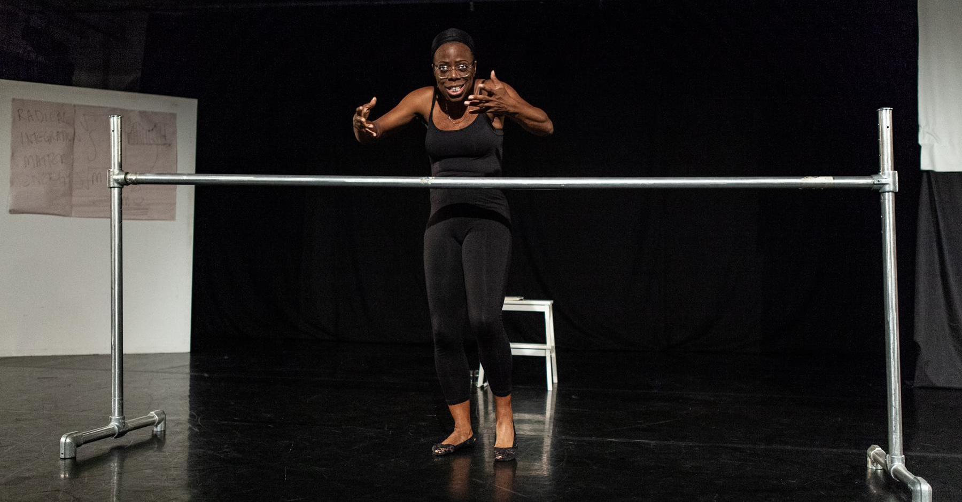

Member Angela Andrew in Radical Integration – a Collaboration between Generations Commission, December 2018. Photo by Zbigniew Kotkiewicz

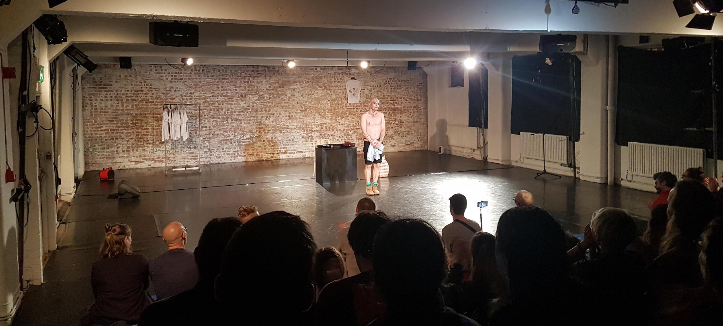
International guest performances - Ivo Dimchev performs Som Faves in November 2018
About the Board of Trustees

Current Team and Trustees

CDS is a registered charity, currently operating with a small but efficient and experienced core team, supported by freelance staff, project staff and volunteers.

Chisenhale Dance Space’s board is composed of individuals, who are legally and ethically responsible for the charity. They are appointed for 3-year terms, which are renewable for up to 3 terms. The current list of trustees and their joining date can be viewed here.

The role of the Board of Trustees is to support the strategic vision and leadership of the
company and ensure Chisenhale Dance Space remains true to its values, relevant to our artistic and local communities, well managed and financially sustainable. Trustees are responsible to ensure the organisation’s values and standards are applied and respected at all levels of operation.

Why become a Trustee?
There are many reasons that people may want to be a Trustee. Here are some that we think are useful:
- To ‘give back’ and use your skills in new contexts
- For personal and professional development, to develop your personal leadership and management skills
- To help contribute to the change that you want to see in the world, the local community or the arts sector
- Get involved with a dynamic, eclectic and heritage-filled artistic community in London, and to link your networks within it as relevant
- To collaborate and work with a motivated and diverse board and staff
- To open up and access new professional networks

Chisenhale Dance Space Board Members are expected to:
- Attend 4 x weekday evening Quarterly Board Meetings per year;
- Attend a least 1 monthly working meetings to facilitate and guide the business of the organisation
- Attend 1 x Members’ AGM and some Members’ meetings;
- Attend 1 x half-day Board Away Day;
- Attend some Chisenhale Dance events and performances
- To take a pro-active lead on an area of work at the organisation, and dedicate some time each month to initiate and support activity in that area. Until April 2022, we expect this could be up to 2 hours per week, depending on the role of the trustee.

We estimate that the time commitment to CDS will amount to a day per month spread out in short meetings and email interactions. This is to meet the needs of the fast-moving changes at the organisation, which offer a great opportunity for the board to actively engage with the work at hand.

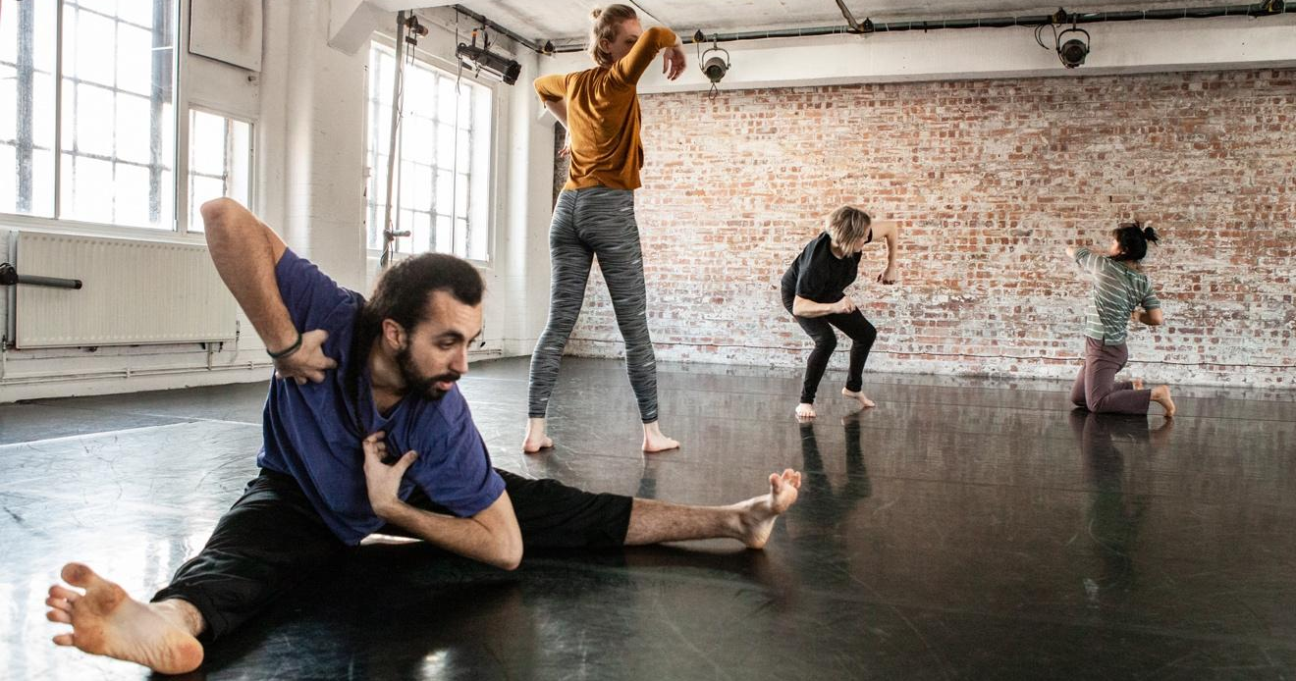

Adult contemporary classes. Photo by Zbigniew Kotkiewicz

Specific Roles - details of vacancies on the board

Trustees’ roles
To ensure efficient support for the staff, and streamline communications, each board member takes on a specific role, which they sometimes share with another board member. The roles define the areas where the board member is expected to be proactive, but does not limit the board member from engaging with other areas of work as is of interest and desired by them. People are not expected to be experts in the area of work covered by the role, but rather to have the enthusiasm and curiosity to engage, learn, and lead on activity related to the roles. Being a trustee is a great opportunity to grow and develop skills in this way.

We have below appointed roles for Trustees, some of which we are currently recruiting for:
- Chair of the Board (recruiting)
- Vice Chair
- Equality, Diversity and Inclusion Lead (recruiting)
- Treasurer (recruiting)
- Human Resources Lead
- Artistic Community Leads (recruiting)
- Building / Legal Leads (recruiting)
- Outreach and Community Lead

Chair of the Board
This is a significant role for the organisation. The Chair is responsible for the health of the board as a democratic, open, safe, inclusive and productive space to govern Chisenhale Dance Space. The Chair of the Board has an overview of all of the board’s and organisation’s activity, and is required to have fortnightly contact with the Director to understand the ongoing shifts and changes of the organisation and support its delivery. While an active hands-on role, it is an amazing opportunity of learning leadership through practice, building strong relationships with individuals across the organisation.

The Chair of the Board is responsible for:
- Having an overview and in-depth understanding of the workings, needs and current risks of Chisenhale Dance Space. Stirring board activity so as to meet the needs of the organisation.
- Scheduling, planning, chairing of quarterly board meetings and the AGM
- Managing, supporting and delegating to the board members to enable active participation in board duties
- Ensuring a smooth and relevant communication process between staff and board
- Managing decision-making processes as and when necessary, compliant with the charity’s governance structure
- Ensure due diligence and sign off of the annual report
- Coordinate the recruitment and induction of new board members when required ensuring that process is in line with the aspired balance of representation of the board
- Creating and holding safe spaces for board members, staff and stakeholders to work together in respect of Chisenhale Dance Space’s Code of Conduct

Desired skills and characteristics:
- Experience of being a trustee for a charitable organisation
- Experience of or readiness for a leadership role in the arts
- Experience of managing a team
- Understanding of and committed to equity, diversity and inclusion
- A good understanding of the UK arts, dance or charitable sectors
- Excellent interpersonal and communication skills

We welcome applications from less experienced people who can demonstrate how they might approach the learning experience and put in place their support network to enable their growth.

Equality, Diversity and Inclusion Lead
They are responsible for ensuring all staff and trustees are held accountable in their actions, through the lens of equality, diversity and inclusion. They support staff to organise the training programme for staff, the board and members for our continuous effort to make CDS truly inclusive organisation.

Desired skills and characteristics:
- Experience of working on improvements regarding equality, diversity and inclusion in organisational contexts
- A passion for equality, diversity and inclusion, with drive and ideas as to how to support processes for accountability

Treasurer
They are responsible for the health of the organisation’s finances. The Treasurer works closely with the Director to ensure efficient and transparent financial management of all of CDS’ operations.

Desired skills and characteristics:
- Experience of financial control and budgeting
- Experience of accounting for charities
- Experience of fundraising for charities

Artistic Community Leads
They are responsible for overseeing the relationship between the board of trustees and the artistic membership, and representing the voices of the creative practitioners today.

Desired skills and characteristics:
- A good understanding of the current contemporary dance sector, particularly from the perspective of independent artists, and their needs
- Applications from the CDS's Artistic Membership community are encouraged
Building Lead
They are responsible for overseeing the lease that Chisenhale Dance Space is bound to for its usage of the studios. The Building lead will understand the intricate relationships with stakeholders including the Borough of Tower Hamlets Council and the other members of the CAPT board, and the strategic overview of a long-term plan for the housing of the organisations.

Desired skills and characteristics:
- Experience of property management
- Experience of initiating, or managing capital projects
- Understanding of, or holding a professional qualification in property law

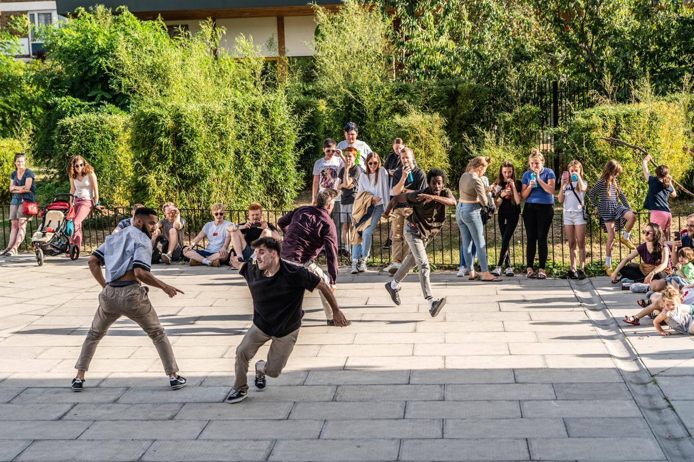
T-Break performance at Encounter Bow festival, September 2019. Photo by Zbigniew Kotkiewicz

How to Apply
Recruitment Process
- Have an informal conversation with a board member (optional)
- Send your CV and a letter expressing your interest, as well as which role(s) you are interested in and why, to theboard@chisenhaledancespace.co.uk.
If a written letter is not the best format of expression for you, we welcome recorded voice and video files as well.
Deadline to do this is 9am, Monday 26 July 2021.
- Eligible candidates will be invited to observe the next board meeting online, 9 August 2021, 5pm-7:30pm
- August - September 2021: formal interviews with 1 trustee of the board and 1 artist member, all online. Decisions made by the end of September 2021.
- October 2021: due diligence checks and procedures. Welcome and induction process, board meeting scheduled end of October
- November 2021: Annual General Meeting

Would you like to have an informal conversation with a board member?
Please email theboard@chisenhaledancespace.co.uk, stating any particular questions or areas of interest you might have, so we can pair you up with the best person to answer these. We can schedule phone/zoom calls at your convenience.
You can ask us anything! We want to hear from you, no matter how unsure you are if this opportunity is right for you.

